**MINI PROJECT**

**(2020-2021)**

**HEALTH & WELLNESS**

**END-TERM REPORT**



**Institute of Engineering & Technology**

**Submitted by-**

**Simran Maurya (181500714)**

**Aishwarya Singh (181500047)**

**Supervised By: -**

**Mr. Anand Kumar Gupta**

**Asst. Professor**

**Mrs. Ruchi Gupta**

**Technical Trainer**

**Department of Computer Engineering & Applications**

**Declaration**

We here by declare that the work which is being presented in the B.Tech. Project **“HEALTH & WELLNESS”**, in partial fulfillment of the requirements for the award of the ***Bachelor of technology*** and submitted to the Department of Computer Engineering and Applications of GLA University, Mathura ,is an authentic record of our own work carried under the supervision of **Mr. Anand Kumar Gupta , Assistant Professor of Computer Engineering Department.**

The contents of this project report, in full or in parts, have not been submitted to any other institute or university for the award of any degree.

|  |  |
| --- | --- |
| Simran Maurya  (181500714) |  |
| Aishwarya Singh  (181500047) |  |
|  |  |

**Certificate**

This is to certify that the project entitled “Health Hunt” carried out in Mini Project – I is a

bonafide work done by Simran Maurya (181500714) and Aishwarya Singh (181500047) and is submitted in complete fulfillment of the requirements for the award of the degree Bachelor of Technology (Computer Science & Engineering).

**Signature of Supervisor:**

**Name of Supervisor: Mr. Anand Gupta**

**Date:21/11/2020**

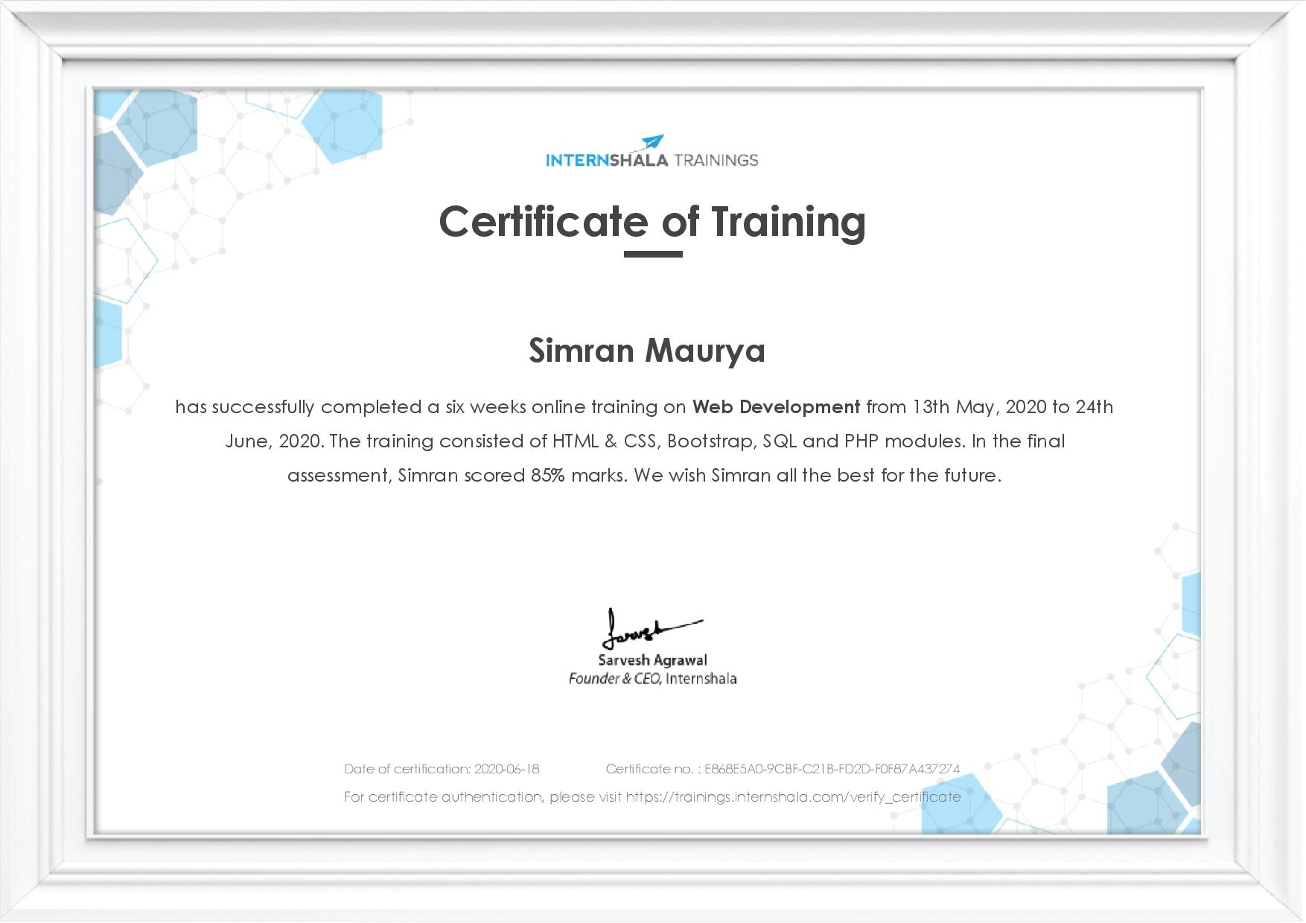

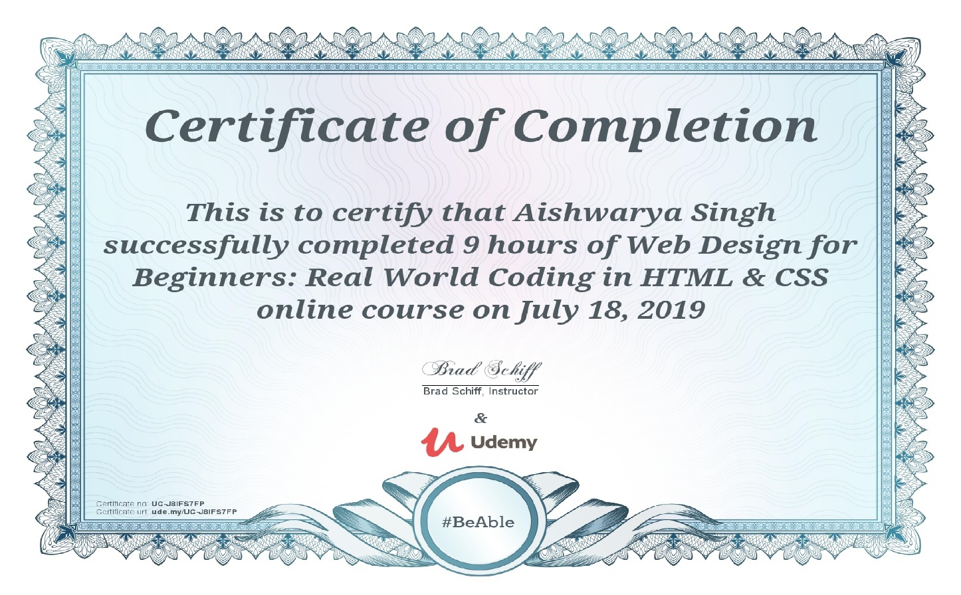

**Acknowledgement**

It gives us immense pleasure to present the report of B. Tech Mini-Project undertaken during B. Tech Third year. We owe special debt of gratitude to Prof. Anand Kumar Gupta, Department of Computer Science & Engineering, GLA University, Mathura for his constant support and guidance throughout the course of our work. His sincerity, toughness and perseverance have been a constant source of inspiration for us.

We also take the opportunity to acknowledge the contribution of Prof. Anand Singh Jalal, Head, Department of Computer Science & Engineering, GLA University, Mathura for his full support and assistance during the development of the project.

We won’t like to miss the opportunity to acknowledge the contribution of all faculty members of the department for their kind assistance and cooperation during the development of our project. Last but not the least, we acknowledge our friends for their contribution in the completion of the project.

|  |  |
| --- | --- |
| Simran Maurya | (181500714) |
| Aishwarya Singh | (181500047) |

**Abstract**

This project “Health Hunt” based on health &wellness was chosen as Mini-Project1 to build a seamless website to provide safe, secure and high-quality medical care, to provide healthy diet plan, to provide health related services to everybody equally, improving health related issues online at the time of pandemics and to aware people about the necessity of routine exercises in their lives. It would not only be easy to access but also pocket friendly. This would also save our time of travelling to a physician in person.

Life has become more complex. With the help of innovating inventions, many household chores can happen in a snap of time. They are convenient modes of transport that make our journey comfortable. Just as every coin has two sides, there are cons to this style of living and the most endangered one being a negative impact on our health. We have started to live a sedentary lifestyle and no longer have the time to focus on our physical fitness and mental wellbeing. To make the best use of technology, one could prefer our website to get relevant solutions to all their health issues on their fingertips. The chatbot used on our portal would be a splendid opportunity to share problems without any hesitation.

The backend of the website stores the details of every user who seeks to visit the website.

Only authorized users can navigate through all the pages. We are user-friendly as we welcome the suggestions of all our users. The contact us form comes into play here

**Contents**

|  |  |  |
| --- | --- | --- |
| **Topic**  Chapter1 Introduction | **Page no**  1 |  |
| 1.1 Problem Statement | 1 |  |
| 1.2 Motivation | 2 |  |
| 1.3 Objective | 3 |  |
| Chapter2 Software Requirement Analysis | 4 |  |
| 2.1 Requirement Analysis | 4 |  |
| 2.1.1 Software Requirement | 4 |  |
| 2.1.2 Hardware Requirement | 5 |  |
| 2.1.3 Technologies Used | 5 |  |
| 2.2 Feasibility Study | 7 |  |
| 2.2.1 Technical Feasibility | 7 |  |
| 2.2.2 Operational Feasibility | 8 |  |
| 2.2.3 Economical Feasibility | 9 |  |
| 2.3 Analysis | 10 |  |
| 2.4 Summary of Modules | 11 |  |
| Chapter3 Software Design | 12 |  |
| 3.1 DFD | 13 |  |
| 3.1.1 DFD Level 0 | 14 |  |
| 3.1.2 DFD Level 1 | 14 |  |
| 3.2 Usecase Diagram  3.2.1 Usecase diagram of Health Hunt | 15  16 |  |
| 3.3 Database Design | 17 |  |
| Chapter 4 Implementation & User Interface | 16 |  |
| 4.1 Task Division 18  4.2 Percentage division 19  4.3 Gantt Chart with Progress 20 |  |  |

|  |  |
| --- | --- |
| Chapter 5 Software Testing | 47 |
| 5.1 Testing | 47 |
| 5.2 Objectives of Software Testing | 47 |
| 5.3 Principles of Software Testing | 48 |
| 5.3.1 White Box Testing | 48 |
| 5.3.2 Black Box Testing | 48 |
| 5.4 Testing Fundamentals | 49 |
| 5.5 Testing Information | 49 |
| Conclusion | 50 |
| References | 51 |

**LIST OF TABLES**

|  |  |  |  |
| --- | --- | --- | --- |
| **S. No.** | **Table Name** | **Table No.** | **Page** |
| **1** | signin | Table 3.1 | 15 |
| **2** | contactus | Table 3.2 | 15 |
|  |

**LIST OF FIGURES**

|  |  |  |  |
| --- | --- | --- | --- |
| **S. No.** | **Figure Name** |  | **Page** |
| **1** | Data Flow Diagram Symbols |  | 10 |
| **2** | 0 level DFD |  | 14 |
| **3** | 1 level DFD |  | 14 |

**LIST OF TABLES**

|  |  |  |  |
| --- | --- | --- | --- |
| **S. No.** | **Table Name** | **Table No.** | **Page** |
| **1** | signin | Table 3.1 | 15 |
| **2** | contactus | Table 3.2 | 15 |
|  |
|  |

* 1. **Introduction**

**Problem Statement:**

There is merely any platform where one can explain its suffering without any hesitation, therefore this site would enact as an open forum where complete package of advisory related to various viral diseases, dietary intakes and necessary exercises would be availed. Depression is still not a recognized problem in our society and people often feel uncomfortable while discussing their problems. To resolve this major problem of being judged, we will keep their identities private. The mental health portal and its chatbot is created for dealing with such issues.

**Proposed System:**

In this project titled ‘Health & Wellness’, we are going to offer people an incredible opportunity to talk and discuss about their health-related issues. People from all over the country could refer this site for their health and wellness. There are many people out there cautious for their family as well as their own health. As the famous phrase says, “Prevention is better than cure” one should stay aware of the right food, exercises that would help them forehand to avoid any intrusion of chronic disease into their lives.

There will be sections related to different ailments. A person would be able to find the section which deals with his or her ailment and disentangle the necessary precautions and medication required. One would be able to get a proper diet chart along with necessary exercise recommendations.

The medication provided on the site would come from trustworthy physicians’ prescriptions and Internet put together.

One-to-one conversation via online chatting with experienced medical practitioners would be available too

.

**1.2 Motivation**

Because of the COVID-19 pandemic, people got to know how important and precious life is. People are dealing with stress and depression every day.  Keeping that in mind our team has decided to provide a platform to people where no pandemic can peep neither today nor in future. Good nutrition is an important part of leading a healthy lifestyle. Combined with physical activity, your diet can help you to reach and maintain a healthy weight, reduce your risk of chronic disease (like heart disease and cancer), and promote your overall health.

Recent medical reports show that there has been a rise in health-related issues like metabolism diseases, joint and skeletal problems, cardiovascular diseases, hypertension and obesity. Research has proven that a healthy lifestyle like appropriate diet, satisfactory physical fitness level and a healthy weight can provide health benefits.

In summary, for many of us, the modern lifestyle and the stress it causes affects our physical, psychological and social health. Hence, it has become vital to understand the relationship and maintain the right balance. By taking the full advantage of Internet, we have decided to give each and everyone, a healthy and wealthy today.

**1.3 Objective**

The purpose of building this website “Health Hunt” is to promote the benefits of this digital word. It’s very easy to use and reliable. COVID-19 made us realize that it is too important to take care of ourselves. When the world came to a standstill, it provoked a sense of duty towards each other, a duty to care. At such times, it won’t be possible to visit any store or a doctor in person. This would help the needy to avail the following benefits at their fingertips.

* To provide health related services to everybody equally
* An initiative to talk about mental health openly
* To emphasise the importance of good diet
* To explain the role of exercises in daily life
* To provide safe, secure and high-quality medical care.
* Improving health related issues online at the time of pandemics.

1. **SOFTWARE REQUIREMENT ANALYSIS**

**2.1 Requirement Analysis**

System Analysis is a detailed study of the various operations performed by a system and their relationship within and outside the system. It is a systematic technique that defines goals and objectives the goal of the development is to deliver the system in the line with the user’s requirements, and analysis is this process.

**2.1.1 Software Requirements**

* Operating System: Window 7 and higher
* VS Code
* Google Chrome
* GitHub
* XAMPP

Four major software requirements for this project were:

* + - * + VS Code: Visual Studio Code is a streamlined code editor with support for development operations like debugging, task running, and version control. It aims to provide just the tools a developer needs for a quick code-build-debug cycle and leaves more complex workflows to fuller featured IDEs, such as Visual Studio IDE. The code of this project is totally written on VS Code be it front-end or back-end. Mini-Project-1 named folder is created on VS Code that contains separate folders of images, css files and JavaScript code. Few files are purely front-end based and saved with .html extension whereas three files namely signup, login, contactUS pages are saved with .php extension since back-end is included in them.
        + GitHub:  GitHub is a code hosting platform for version control and collaboration. It lets you and others work together on projects from anywhere. This tutorial teaches you GitHub essentials like repositories, branches, commits, and Pull Requests. Since, we are a team of two members therefore we worked in collaboration. In our project, we made approx. 90 commits. In fact, every little changes made in files were uploaded on GitHub on the same day. The changes made by one member were pulled and acknowledged by the other one. Before pushing the changes on the server, we made sure to write the commit description signifying the changes made or the content added.
        + XAMPP: XAMPP is an abbreviation for cross-platform, Apache, MySQL, **PHP** and Perl, and it allows you to build WordPress site offline, on a local web server on your computer. This simple and lightweight solution works on Windows, Linux, and Mac – hence the “cross-platform” part. In our project, two databases were made. One was to store the information of the user who signed in using sign up form and the other was made to store any message sent by the user using contact us form.
        + Google Chrome: Chrome is a free Internet browser officially released by Google on December 11, 2008. Its features include synchronization with Google services and accounts, tabbed browsing, and automatic translation and spell check of web pages. It also features an integrated address bar/search bar, called the omnibox. Every file we made during this project was ultimately executed on google chrome be it for desktop screen or mobile screen.

**2.1.2 Hardware Requirements**

* Memory 4GB RAM (or higher)
* Intel core i3 64bit Processor (or higher)

# 2.1.3 Technologies Used

* **Front- End Technology:**
* HTML5
* CSS
* Bootstrap
* JavaScript
* jQuery

**1.HTML**: Hypertext Markup Language (HTML) is the standard [markup language](https://en.wikipedia.org/wiki/Markup_language" \o "Markup language) for documents designed to be displayed in a [web browser](https://en.wikipedia.org/wiki/Web_browser). It can be assisted by technologies such as [Cascading Style Sheets](https://en.wikipedia.org/wiki/Cascading_Style_Sheets) (CSS) and [scripting languages](https://en.wikipedia.org/wiki/Scripting_language) such as [JavaScript](https://en.wikipedia.org/wiki/JavaScript). [Web browsers](https://en.wikipedia.org/wiki/Web_browser) receive HTML documents from a [web server](https://en.wikipedia.org/wiki/Web_server) or from local storage and [render](https://en.wikipedia.org/wiki/Browser_engine) the documents into multimedia web pages. HTML describes the structure of a [web page](https://en.wikipedia.org/wiki/Web_page) [semantically](https://en.wikipedia.org/wiki/Semantic_Web) and originally included cues for the appearance of the document.

**2.CSS:** CSS is the language for describing the presentation of Web pages, including colors, layout, and fonts. It allows one to adapt the presentation to different types of devices, such as large screens, small screens, or printers. CSS is independent of HTML and can be used with any XML-based markup language.  
  
**3. BOOTSTRAP**: Bootstrap is a potent front-end framework used to create modern websites and web apps. It's open-source and free to use, yet features numerous HTML and CSS templates for UI interface elements such as buttons and forms. Bootstrap also supports JavaScript extensions.

**4. JAVASCRIPT**: JavaScript is a text-based programming language used both on the client-side and server-side that allows you to make web pages interactive. Where HTML and CSS are languages that give structure and style pages, JavaScript gives web pages interactive elements that engage a user.

**5.jQuery**: jQuery is a lightweight, "write less, do more", JavaScript library. The purpose of jQuery is to make it much easier to use JavaScript on your website. jQuery takes a lot of common tasks that require many lines of JavaScript code to accomplish, and wraps them into methods that you can call with a single line of code.

* **Back-end Technology and Tools:**
* PHP
* MySQL

**1.PHP**: PHP is a server-side scripting language. that is used to develop Static websites or Dynamic websites or Web applications. PHP stands for Hypertext Pre-processor, that earlier stood for Personal Home Pages. PHP scripts can only be interpreted on a server that has PHP installed. In this project, back-end part was embedded into html code using php.

**2.SQL:** SQL (Structured Query Language) is a special-purpose language developed to work with relational databases. More specifically it’s used to manage and manipulate data in those databases. In this project, user info and user feedbacks were stored in database using sql queries.

## Feasibility Study

Feasibility study is the process of determination of whether or not a project is worth doing. Feasibility studies are undertaken within tight time constraints and normally culminate in a written and oral feasibility report. I have taken a fixed time in feasibility study with my co-developer. The contents and recommendations of this feasibility study helped us as a sound basis for deciding how to precede the project. It helped in taking decisions such as which software to use, hardware combinations ,etc.

#### Technical feasibility:

This is concerned with specifying equipment of software and hardware that will successfully satisfy the user requirements. The technical needs of the system may vary considerably, but might include:

* The facility to produce output in a given time.
* Response time under certain condition.
* Ability to produce a certain volume of transaction at a particular speed.
* In examining technical feasibility, configuration of the system is given more importance than the actual makes of hardware. The configuration should give the complete picture about the system requirements. What speeds of input and output should be achieved at particular quality of printing.

According to the definition of technical feasibility the compatibility between front-end and back-end is very important. In our project the compatibility of both is very good. The degree of compatibility of PHP and SQL Server is very good. The speed of output is very good when we enter the data and click button then the response time is very fast and give result very quick. In ever find difficulty when we use complex query or

heavy transaction. The speed of transaction is always smooth and constant. This software provides facility to communicate data to distant location.

We use Active Server Pages and JavaScript. The designing of front-end of any project is very important so we selected Active Server Pages, HTML & CSS as front-end due to following reason:

* + Easy implementation of code.
  + Well define interface and database.
  + Well define hand shaking of SQL Server

At present scenario a no. of backend technologies are available but we have selected SQL Server 2008 because of the following number of reasons.

* + - Able to handle large data.
    - Security.
    - Robust RDBMS
    - Backup & Recovery

With the help of above support, we remove defect of existing software. In future we can easily switch over any platform. To ensure that system does not halt in case of undesired situation or events. Problem effected of any module does not affect any module of the system. A change of hardware does not produce problem.

#### Operational Feasibility:

It is mainly related to human organizational and political aspects. The points to be considered are:

* + - * What changes will be brought with the system?
      * What organization structures are distributed structures are distributed.
      * What new skills will be required? Do the existing staff members have these skills? If not, can they be trained in due course of time?

At present stage all the work is done manually. So, throughput and response time is too much. Major problem is lack of security check that should have been applied.

Finding out the detail regarding user’s request was very difficult, because data store was in different registers and different places. In case of any problem, no one can solve the problem until the person responsible is not present.

Current communication is entirely on telephonic conversation or personal meetings. Post computerization staff can interact using internet.

Now, we will explain the last point of operational feasibility i.e. handling and keeping of software, at every point of designing I will take care that menu options are not too complex and can be easily learned and required least amount of technical skills as operators are going to be from non-computers background.

#### Economic feasibility:

Economic analysis is the most frequently used technique for evaluating the effectiveness of a proposed system. More commonly known as cost/benefit analysis: the procedure is to determine the benefits and saving that are expected from a proposed system and compare them with cost. If benefits outweigh cost, a decision is taken to design and implement the system. Otherwise, further justification or alternative in the proposed system will have to be made if it is to have a chance of being approved. This is an ongoing effort that improves in accuracy at each phase of the system life cycle.

At present Company has ten systems with following configuration:

* + - * Ram 4 GB or above for fast execution and reliability
      * MOTHER Board x64 based PC
      * Color Monitor 14” and17”
      * Hard Disk 100GB
      * Hence the economic feasibility is very good.

## Analysis

System analysis is the first step towards the software building process. The purpose of system analysis is to understand the system requirements, identify the data, functional and behavioral requirements and building the models of the system for better understanding of the system.

In the process of system analysis, one should first understand that, what the present system is, how it works (i.e. processes). After analyzing these points, we become able to identify the problems in the present system. Upon evaluating current problems and desired information (input and output to the system), the analyst looks towards one or more solutions. To begin with, the data objects, processing functions, and behavior of the system are defined in detail. After this model, from three different aspects of the system-data, function and behavior. The models created during the system analysis process helps in better understanding of data and control flow, functional processing, operational behavioral and information content.

* 1. Summary of Module
* Signup/Login
* Chatbot

**Signup/Login**

The administrator is responsible for maintaining Database of web portal. This module will update information of user details. Administrator will also manage the records for users.

**Chatbot**

This portal allows to ask queries from the “Put your queries here…” label and also provide live sessions via Zoom or any other platform.

**Software Design**

A software design document (SDD) is a written description of a [software](http://en.wikipedia.org/wiki/Software) product, that a software designer writes in order to give a [software development](http://en.wikipedia.org/wiki/Software_development) team overall guidance to the architecture of the software project. An SDD usually accompanies an architecture diagram with pointers to detailed feature specifications of smaller pieces of the design. Practically, a design document is required to coordinate a large team under a single vision. A design document needs to be a stable reference, outlining all parts of the software and how they will work. The document is commanded to give a fairly complete description, while maintaining a high-level view of the software.

There are two kinds of design documents called HLDD (high-level design document) and LLDD (low-level design document).

The SDD contains the following documents:

* 1. The [**data design**](http://en.wikipedia.org/wiki/Data-driven_design) describes structures that reside within the software. Attributes and relationships between [data objects](http://en.wikipedia.org/wiki/Data_object) dictate the choice of [data structures](http://en.wikipedia.org/wiki/Data_structures).
  2. The [**architecture design**](http://en.wikipedia.org/wiki/Software_architecture) uses information flowing characteristics, and maps the min to the program structure. The transformation mapping method is applied to exhibit distinct boundaries between incoming and outgoing data. The data flow diagrams allocate control input, processing and output along three separate modules.
  3. The [**interface design**](http://en.wikipedia.org/wiki/Interface_design) describes internal and external program interfaces, as well as the design of human interface. Internal and external interface designs are based on the information obtained from the analysis model.
  4. The [**procedural design**](http://en.wikipedia.org/wiki/Procedural_design) describes structured programming concepts using graphical, tabular and textual notations. These design mediums enable the designer to represent procedural detail that facilitates translation to code. This blueprint for implementation forms the basis for all subsequent software engineering worked.

## Data Flow Diagram (DFD)

The Data Flow Diagram (DFD) is a graphical representation of the flow of data through an information system. It enables you to represent the processes in your information system from the viewpoint of data. The DFD lets you visualize how the system operates, what the system accomplishes and how it will be implemented, when it is refined with further specification.

* Data flow diagrams are used by systems analysts to design information-processing systems but also as a way to model whole organizations. You build a DFD at the very beginning of your business process modeling in order to model the functions your system has to carry out and the interaction between those functions together with focusing on data exchanges between processes. You can associate data with conceptual, logical, and physical data models and object-oriented models.

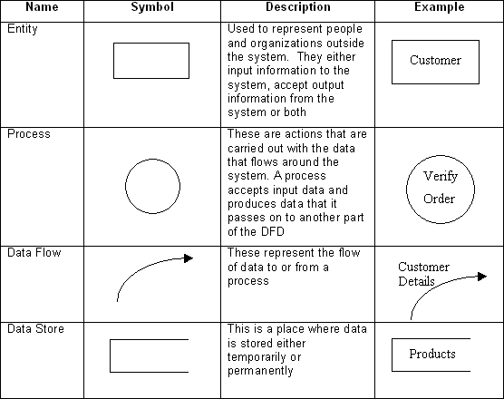

#### Fig 3.1: Data Flow Diagram Symbols

**3.1.2 DFD**

**Customer management**

**Login & Sign Up**

**Diagnosis & Conditions Management**

**Portal Notification Check**

**Fig 3.3.1: 0 Level DFD**

**Manage medicine details**

**Admin**

**Manage website details**

**Manage Customer Details**

**Timely consultation to doctors via phone calls or video calls**

**Daily healthy diet and diet when ill**

**Exercises for good health**

**Information about various diseases**

**Cautions & advices for healthy living**

**Fig 3.3.2: 1 Level DFD**

In 0 level DFD, all students can fill their login to get in DOCUMENT MANAGEMENT SYSTEM (project) and then all of them can apply for the approval of documents.

In 1 level DFD, the admin and students can login by providing the valid username and password. After that student can apply for the approval form and the admin can proceeded for the further process after getting the pop-up on the screen for the approval for retrieval of documents.

* 1. **Use case Diagram**

A [UML](https://en.wikipedia.org/wiki/Unified_Modeling_Language) use case diagram is the primary form of system/software requirements for a new software program underdeveloped. Use cases specify the expected behavior (what), and not the exact method of making it happen (how).

## 3.2.1 How to Draw a Use Case Diagram?

Use case diagrams are considered for high level requirement analysis of a system. When the requirements of a system are analyzed, the functionalities are captured in use cases.

We can say that use cases are nothing but the system functionalities written in an organized manner. The second thing which is relevant to use cases are the actors. Actors can be defined as something that interacts with the system.

Actors can be a human user, some internal applications, or may be some external applications. When we are planning to draw a use case diagram, we should have the following items identified.

* Functionalities to be represented as use case
* Actors
* Relationships among the use cases and actors.

Use case diagrams are drawn to capture the functional requirements of a system. After identifying the above items, we have to use the following guidelines to draw an efficient use case diagram

* The name of a use case is very important. The name should be chosen in such a way so that it can identify the functionalities performed.
* Give a suitable name for actors
* Show relationships and dependencies clearly in the diagram.
* Do not try to include all types of relationships, as the main purpose of the diagram is to identify the requirements.
* Use notes whenever required to clarify some important points.

**3.2.2 Usecase diagram of HEALTH HUNT**

WEBSITE MANAGER

CUSTOMER

**3.3 Database Design**

A good database design is crucial for a high-performance application, just as an Aerodynamic body is important to a race car. If the car doesn’t have smooth lines, it will produce drag and go slower. Without optimized relationships, your database won’t perform as efficiently as possible. Thinking about relationships and database efficiency is part of normalization.

Beyond the issue of performance is the issue of maintenance—your database should be easy to maintain. This includes storing only a limited amount (if any) of repetitive data. If you have a lot of repetitive data and one instance of that data undergoes a change (such as a name change) ,that change has to be made for all occurrences of the data. To eliminate duplication and enhance your ability to maintain the data, you might create a table of possible values and use a key to refer to the value. That way, if the value changes names, the change occurs only once in the master table. The reference remains the same throughout other tables.

|  |  |  |  |
| --- | --- | --- | --- |
| **Attribute** | **Type** | **Description** | **Constraints** |
| id | int(255) | Contains serial count of user | Primary Key, Auto-increment |
| email_id | varchar(255) | Email-id of user | Not null |
| password | varchar(255) | Password of user | Not null |

#### Table 3.1: User Signup/Login

|  |  |  |  |
| --- | --- | --- | --- |
| **Attribute** | **Type** | **Description** | **Constraints** |
| id | int(255) | Contains serial count of user | Primary Key |
| name | varchar(255) | Username | Not null |
| email_id | varchar(255) | Email-id of user | Not null |
| subject | varchar(255) | Issue on which user fills the contact us form | Not null |
| message | varchar(255) | The message user wants to send to admin | Not null |

**Table 3.2: ContactUs**

**4. Implementation and User Interface**

**4.1 Task Division**

The task is equally divided between the two members. Since, the Front-end covers 73% part of the entire project, of which 36.5% is designed by each of the members.

Each week a responsive layout of a particular page of the website is designed. The report of percentage task completion with GitHub link and proper screenshot is being shared to the mentors via WhatsApp.

The chatbot was included and managed completely by Aishwarya Singh.

The back-end part was solely created be Simran Maurya.

Each page consists of 8% of the entire front-end except Login and Sign Up which are 4% each and Homepage which comprises 9% of the entire Front-end.

The rest 27% of the project comprises of Back-end functionalities which includes codes in PHP and storing records in database using MySQL.

The Back-end functionalities are added in Login, Sign Up and Contact Us pages. The records entered in these pages will get stored in database, reviewed and modified accordingly.

**4.2 Progress of modules**

* 1. **Gantt Chart with progress**

**MONTHS**

September

November

October

August

**TASKS**

**4.4 Pages Description**

1. **Index Page**

This is the landing page of the website from where the user can Login or Sign Up for the Homepage and then can use the other features of the website. There is an anchor tag at right side of the screen which is the link to homepage of the website. The mobile view has a plain solid background. This page consists of a responsive navbar which allows the user to navigate through different pages of the website.

1. **Sign Up Page**

This is the page which allows user to register himself/herself for a new account. It’s a first time registration. On filling up the details on the signup form, the page is redirected to back-end of this page(registration.php) that adds the data provided by the user to the database on the condition if it’s a new one. Duplicate entry of data is restricted her. Once the user signs in, next task is to login to his/her registered id to explore the benefits of the website.

1. **Log In Page**

This is the page that allows the a valid user(registered user on signup form whose entry exists in database) to navigate through various pages of the website. On filling up the details on the login form, the page is redirected to back-end of this page(validation.php). Here, if the user entry matches with any entry of database then the server authenticates the user to visit the homepage of the website, failing this condition results into an error that emailed or password is incorrect i.e. the user needs to fill the details again on the login form. This validation therefore allows only registered users to go through the website.

1. **Contact Us**

This page allows the user to share reviews, suggestions, inquiries and comments related to the website by filling a form. The form is redirected to back-end script(contactScript.php) that inserts the details like name, email-id, subject and

message into the database. This makes the website user-friendly as it welcomes all kinds of feedbacks.

Another remarkable validation imposed at this page is that incase a user presses the ‘Send Message’ link mistakenly without filling all the details then an error message prompts at the screen requesting the user to please fill all the blanks before submitting the form. This page also provides the location of our workplace.

1. **Testimonials**

This page let the user know about the owners of the website (i.e. about us). This page consists of a navigation bar which will take the user to different pages. There is a slider at the bottom of the page displaying the reviews of few of our top customers along with their name and picture. Here JavaScript comes into the play as it allows dynamic movement of the slider switching from one comment to the other. At a time, only 3 reviews are shown. The footer of the page will guide the user to different social medias where they can directly connect to us without any trouble.

1. **Homepage**

This is the most crucial part of the website. Once the user logged in or signed up, he’ll be directed to this page. There are several links in the form of divs here. These are linked to four different pages namely conditions & diagnosis (from where he can check about different viral diseases), daily diet(healthy diet one should follow), yoga & exercises and the mental health portal(a portal where a user can address his/her problem). The functioning of navigation bar and footer remains the same in this.

1. **Conditions & Diagnosis**

This page will let the user know about the viral diseases, their symptoms, their preventions and their treatments. The page will bring a basic understanding of the viral diseases without any expensive medications. There are several sections in the same page with a link to reach the top of the page after each section. The page is really informative and contains the link that redirects the user to full details of the diseases. This enhances the readability of the page. The page is really informative and contains the link that redirects the user to full details of the diseases.

1. **Daily Diet**

This page talks about the healthy diet that one should have on a daily basis with the regular meal. The diet mentioned in the page are few selected ones which will help in building good health both mentally and physically. The food items are arranged in the form of thumbnails(a class of bootstrap) which adds responsiveness to the page. On clicking an image, opens it in a larger size giving further details of its nutritious composition and explains why it is healthy to consume it.

1. **Exercises**

This page talks about the Yogasanas that one can perform to avoid body aches without any medication. The page talks about the most important yogasanas. Each yogasana posture in combination with its benefits is posted. There is an anchor tag along with each yogasana which is a link that redirects the reader to furthermore details, Yogasans helps in bringing peace to mind and calmness in behavior.

The art of practicing yoga helps in controlling an individual’s mind, body and soul. It brings together physical and mental disciplines to achieve a peaceful body and mind. It is highly recommended by many well-known specialists these days. This is the reason why we added this extremely important routine to our project.

1. **Portal**

This page is the main highlight of our project. Talking about mental health improve our communities by making it more acceptable for those suffering from mental illness to seek help, learn to cope, and get on the road to recovery. It’s about maintaining a positive state of well-being. The page begins with the knowledge of what is mental health and what are the easy warning signs of this problem. It discusses about how one can build its own support system (consists of members who can guide truly and take good care). There are special guidelines for parents and caregivers. A helpline number is also added to seek immediate assistance.

This page allows the user to directly connect to our specialists and share his/her problem without the hesitation of being judged because the identity will not be shared. This portal allows to ask queries from the “Put your queries here…” label and also provide live sessions via Zoom or any other platform. The meeting IDs will be provided to the attendees.

**4.5Some Screenshots**

Landing Page (Desktop View)

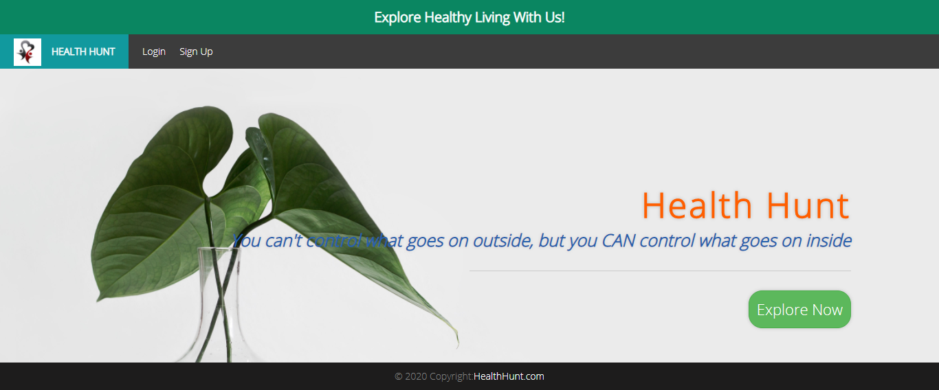

Landing Page (Mobile View)

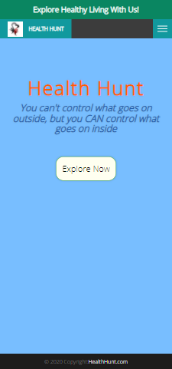

Sign Up Page(Desktop View):-

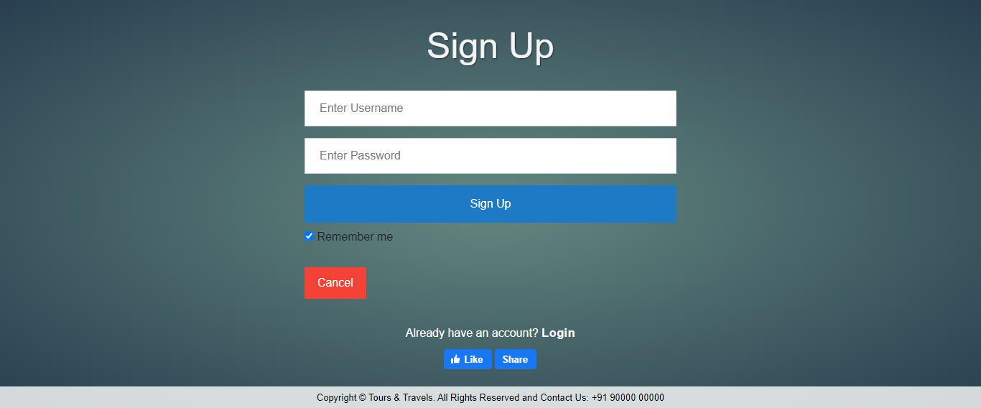

Sign Up Page(Mobile View)

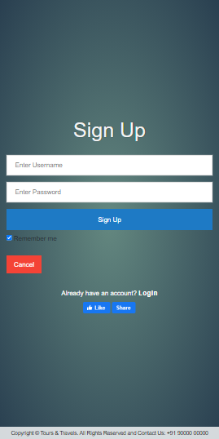

Working of backend:-

On filling up the details on the signup form, the page is redirected to back-end of this page that adds the data provided by the user to the database on the condition if it’s a new one.

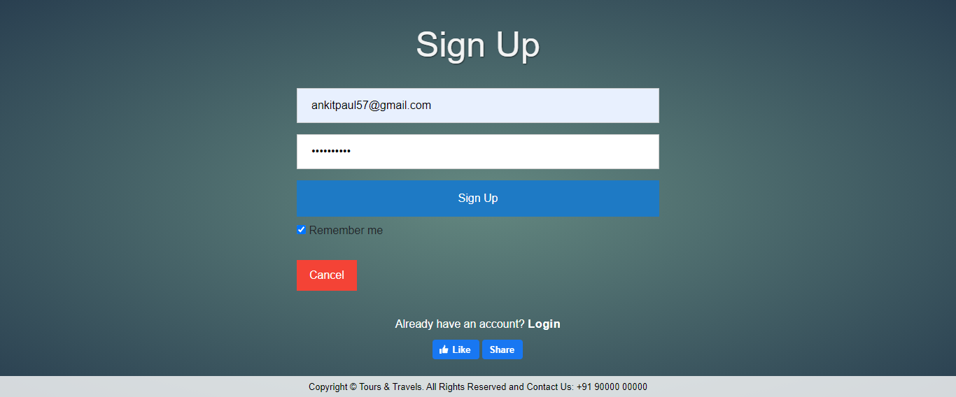

User data inserted into database

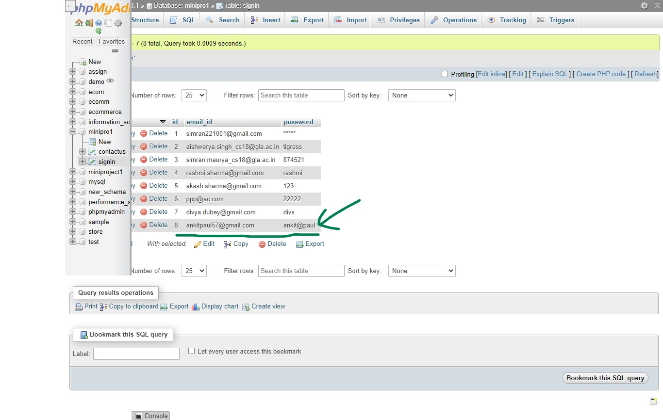

Duplicate entry of data is restricted her. An error message prompts at the screen to sign in form a different account.

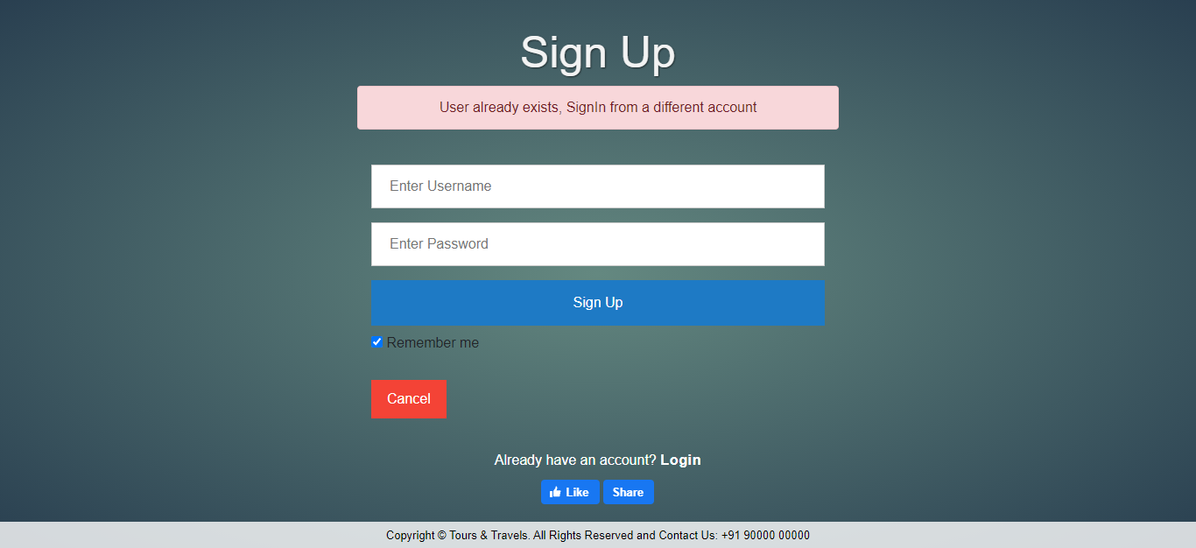

Login page ( Desktop View)

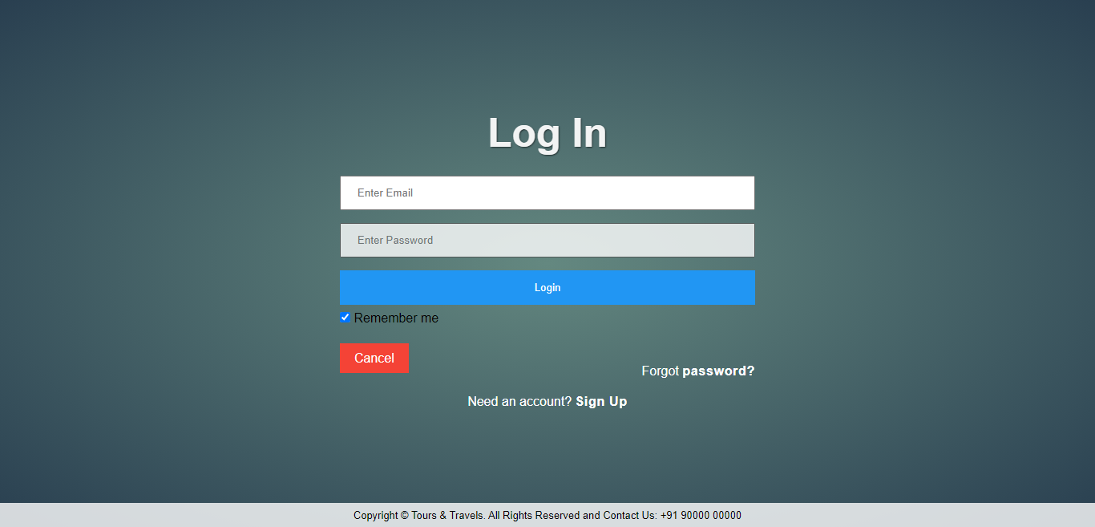

Login page ( Mobile View)

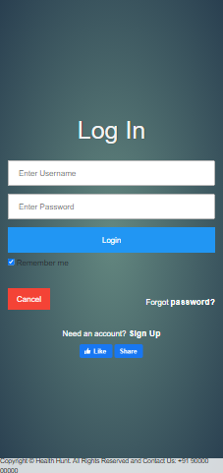

Working of backend

If the user entry doesn’t match with any entry of database ,this condition results into an error that email id or password is incorrect. Here, email id is filled wrongly.

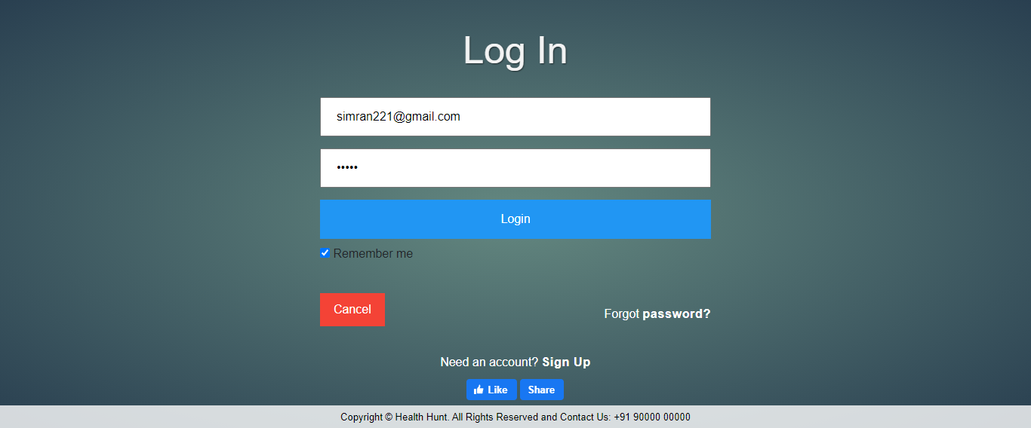

The actual id in the database is as shown in the picture:

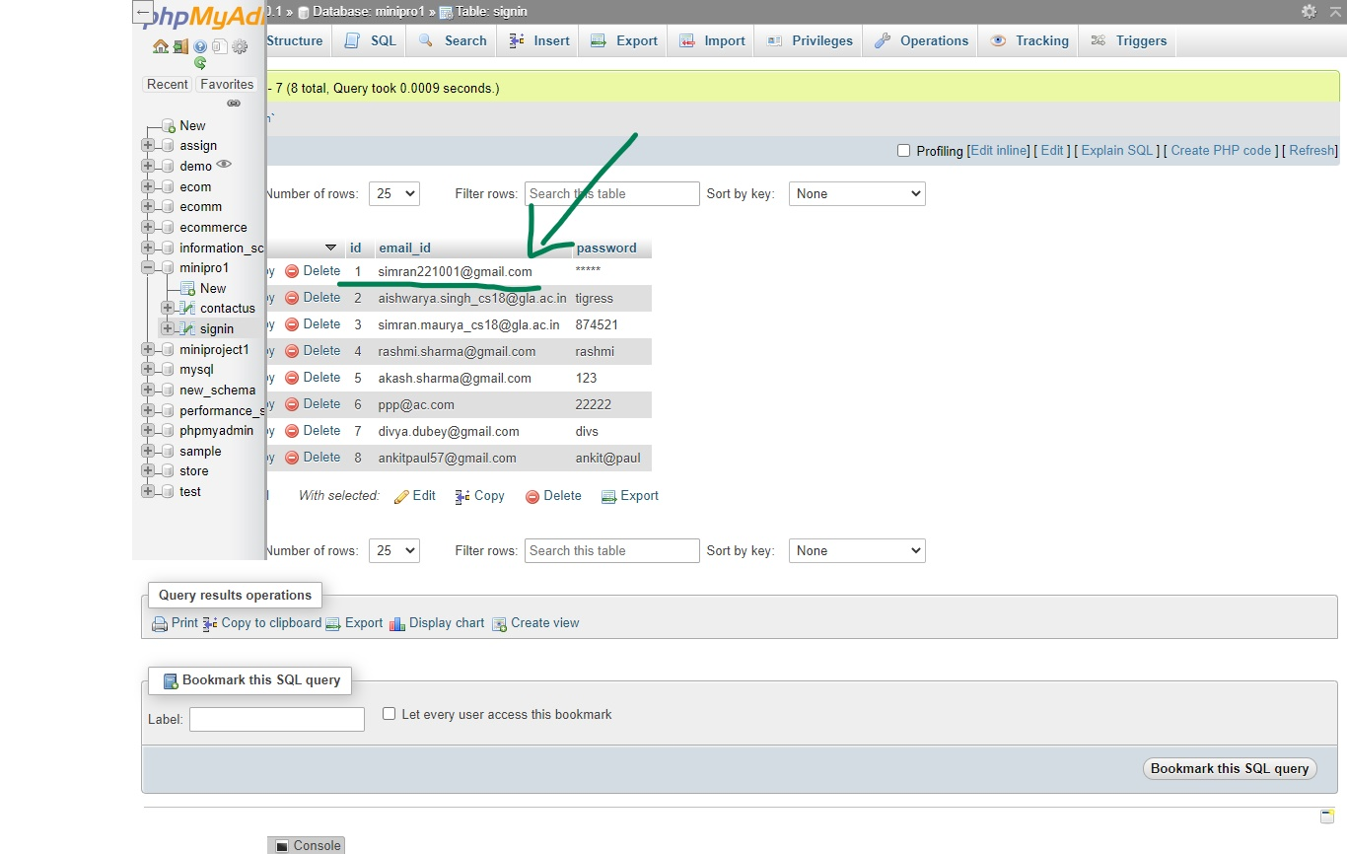

Therefore, the error message prompts at the screen requesting the user to fill the details again.

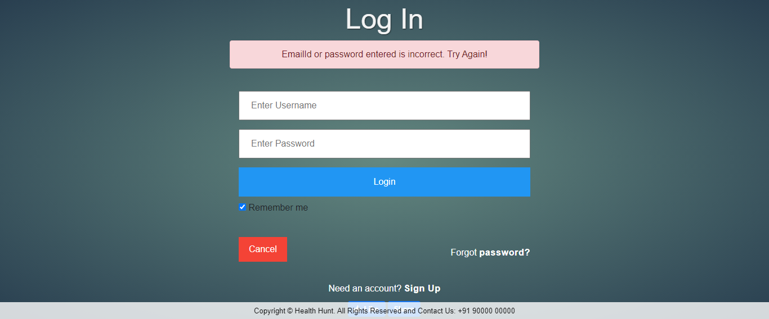

Contact Us Page (Desktop view)

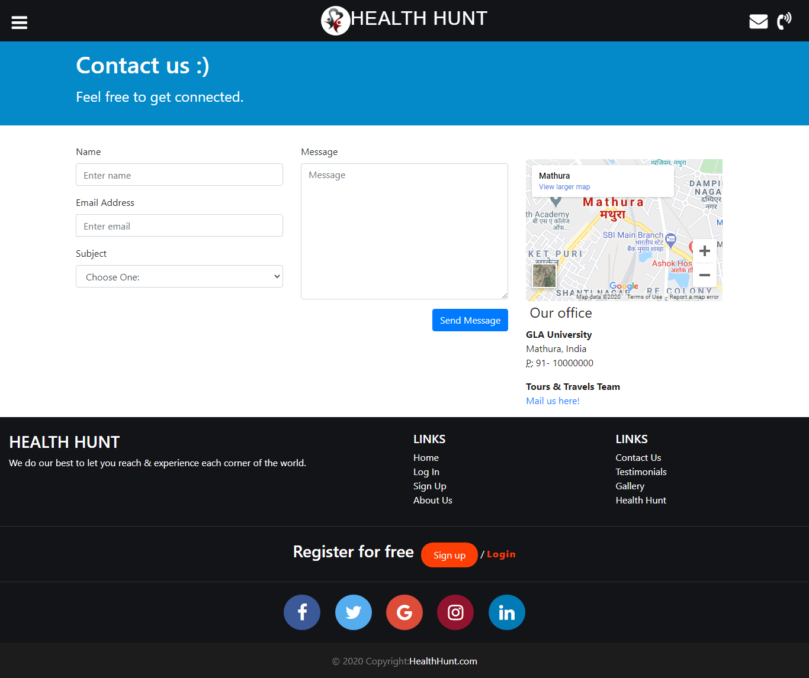

Contact us Page (Mobile View)

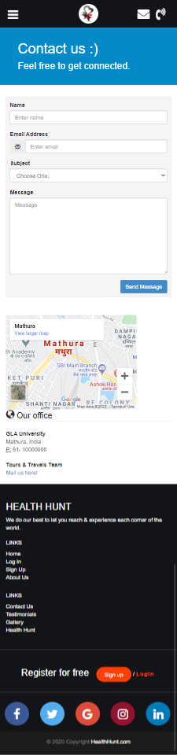

Working of backend:-

The validation imposed at this page is that incase a user presses the ‘Send Message’ link mistakenly without filling all the details then an error message prompts at the screen. Here, email id of user not given.

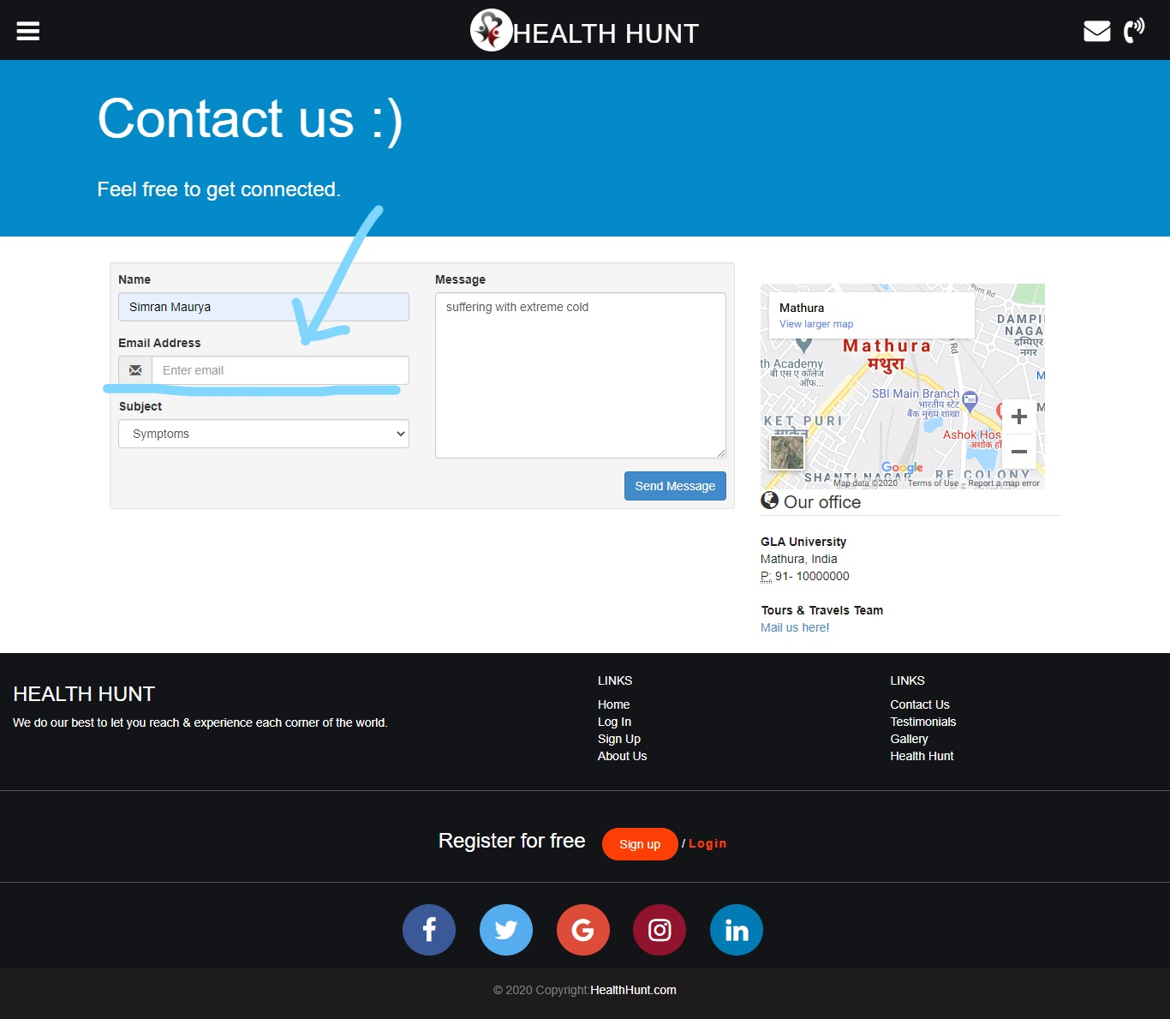

The dialog box requests the user to please fill all the blanks before pressing send.

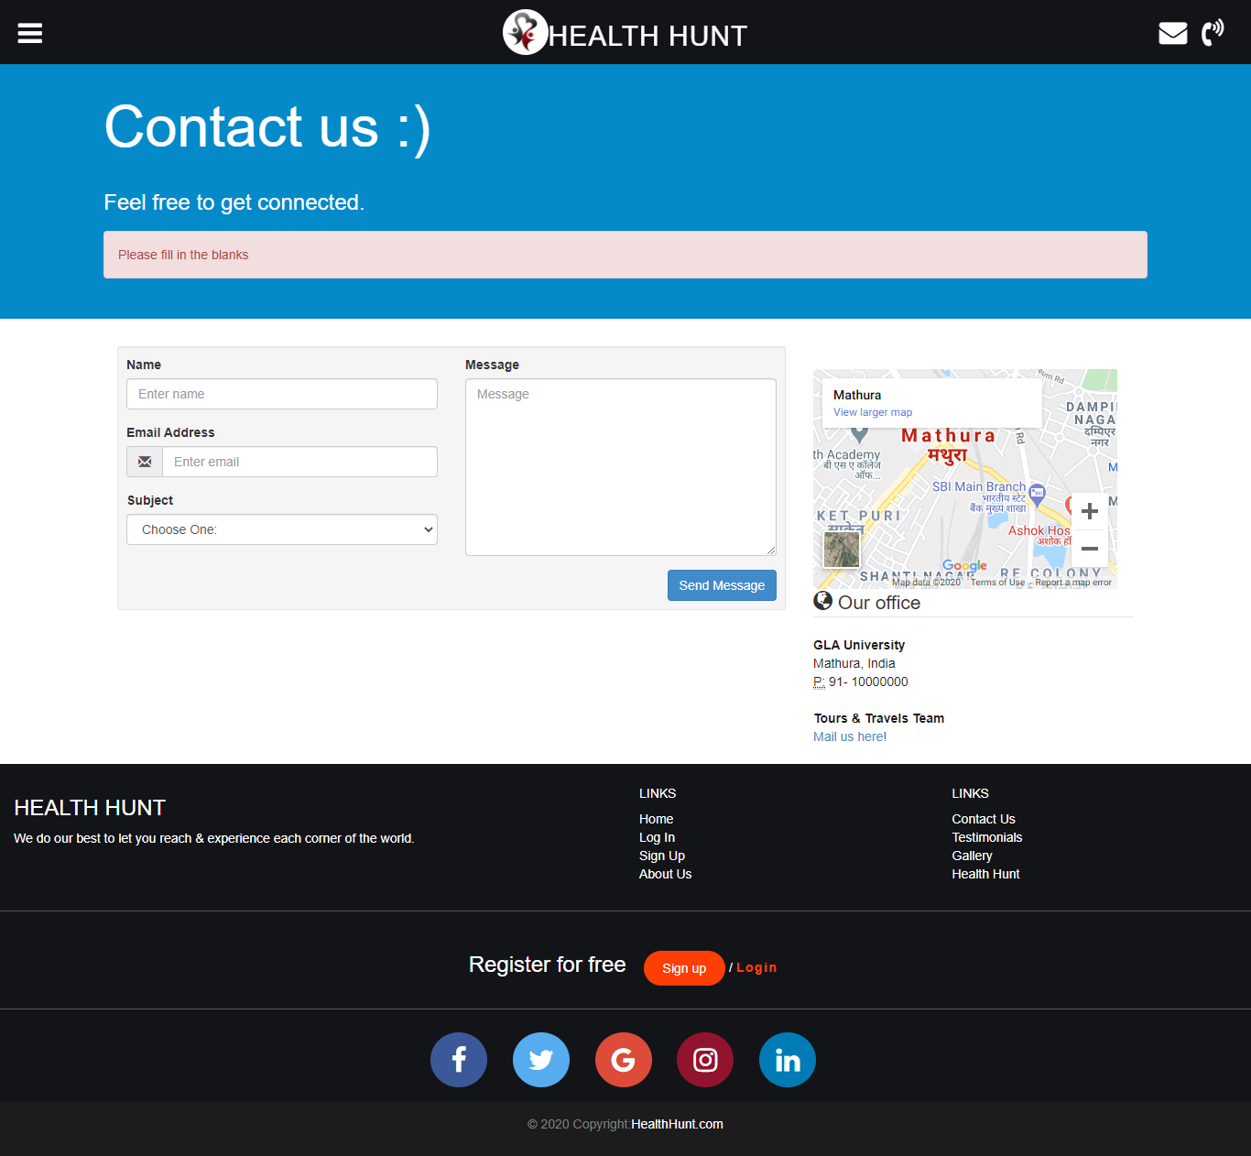

On filling all the details, the feedback gets stored in the database.

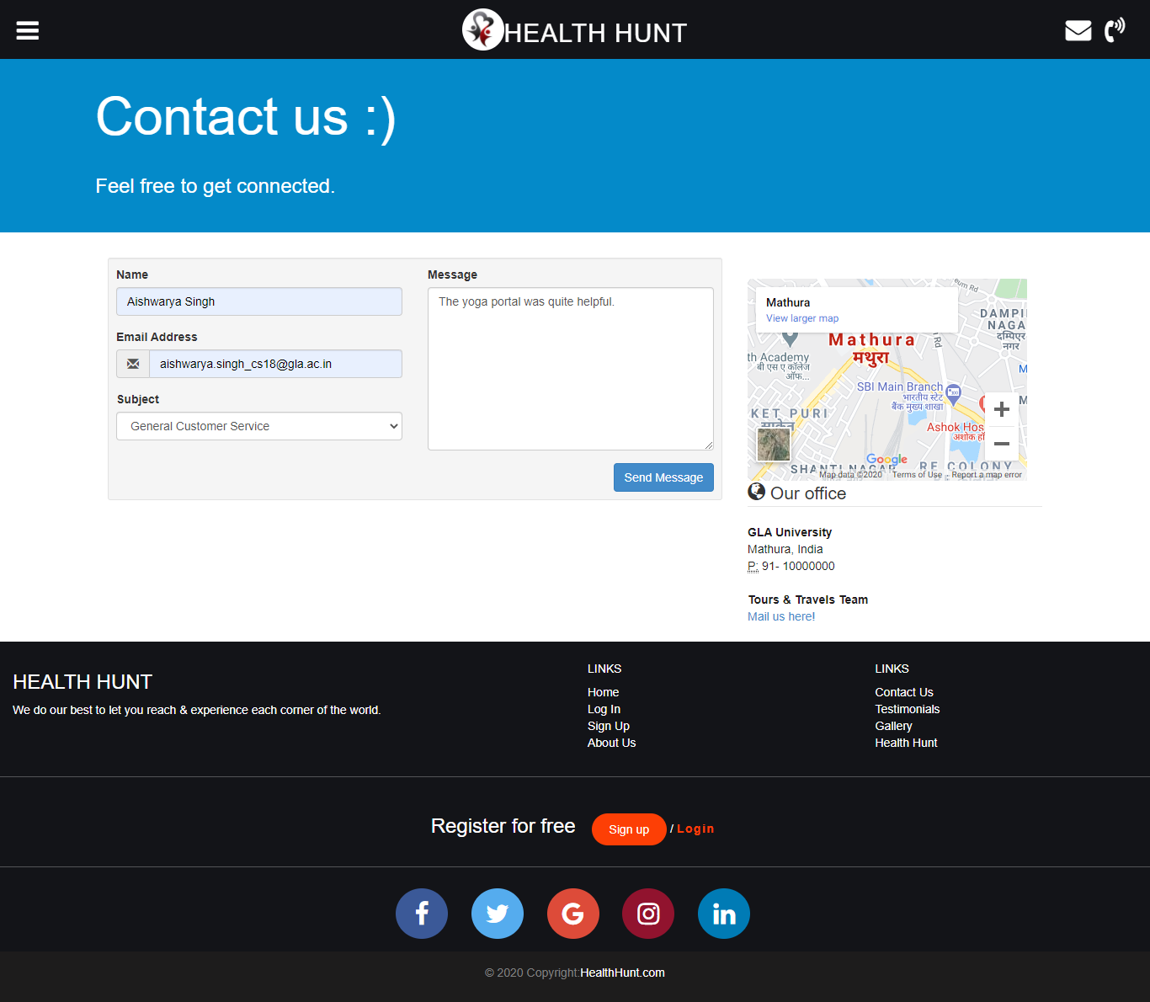

The values get inserted in the contactUs table.

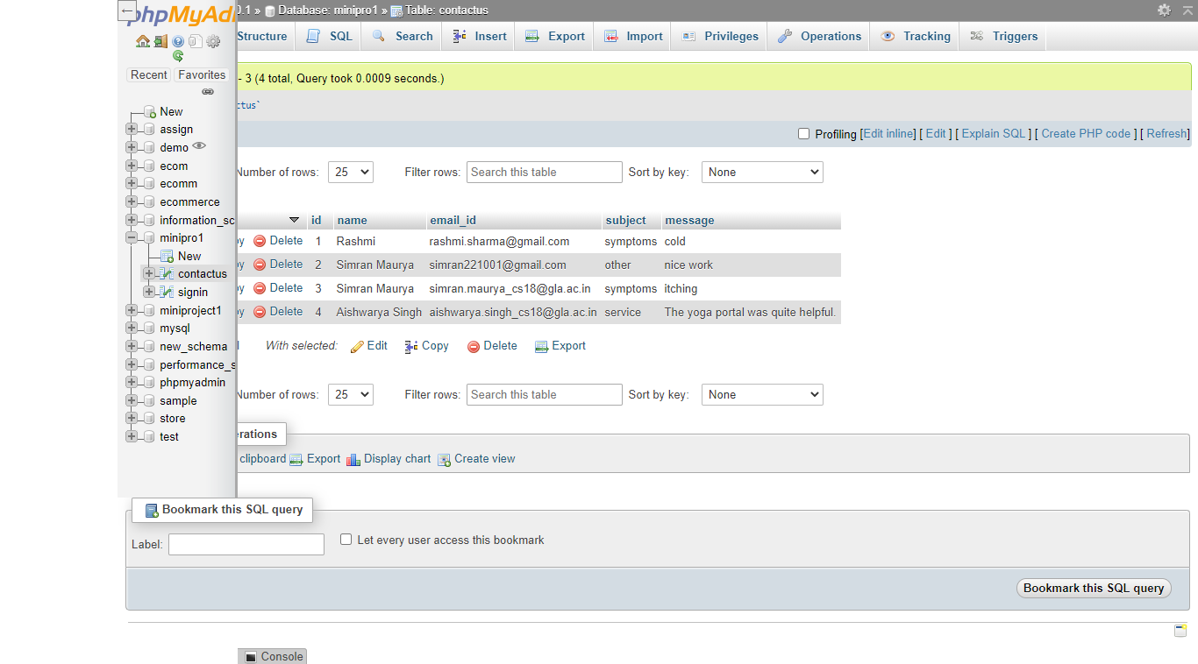

Testimonials Page (Desktop view)

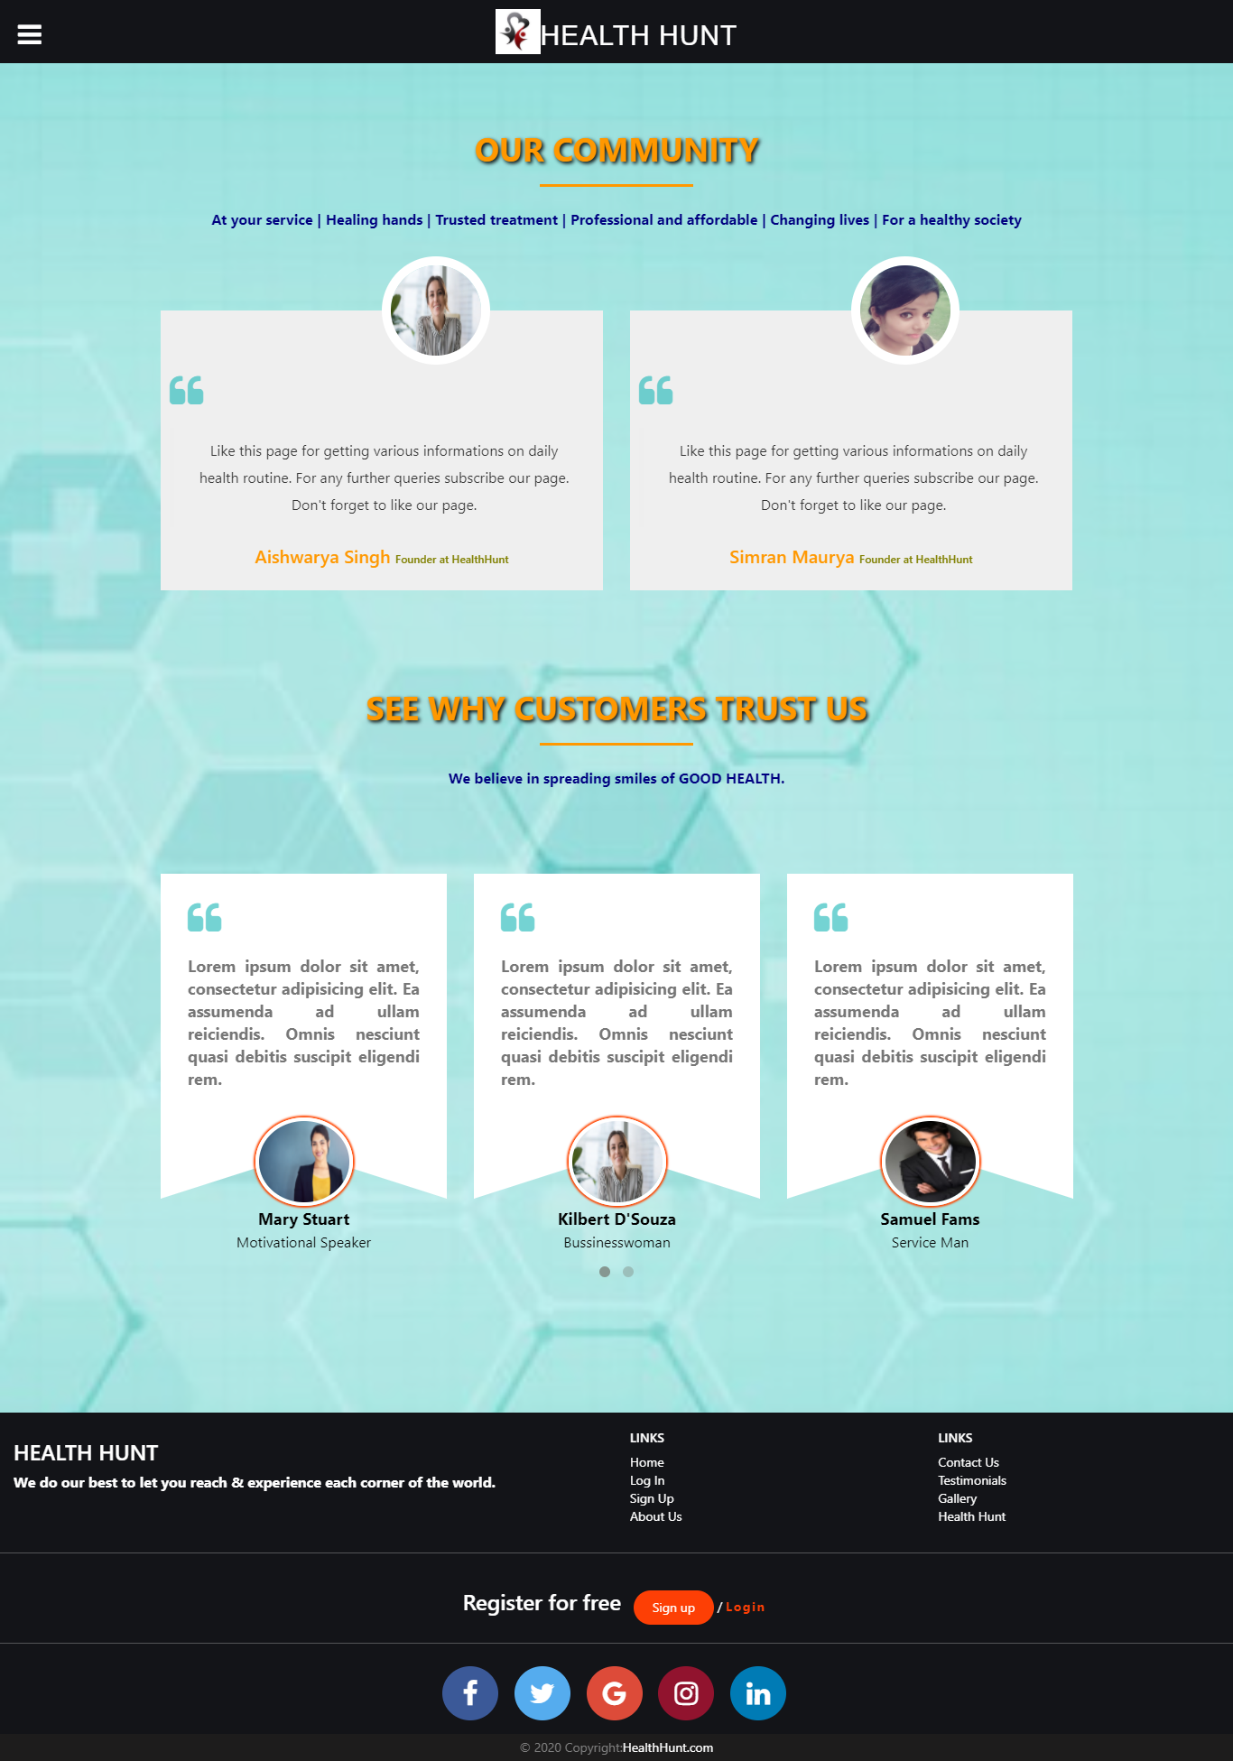

Testimonials Page (Mobile view)

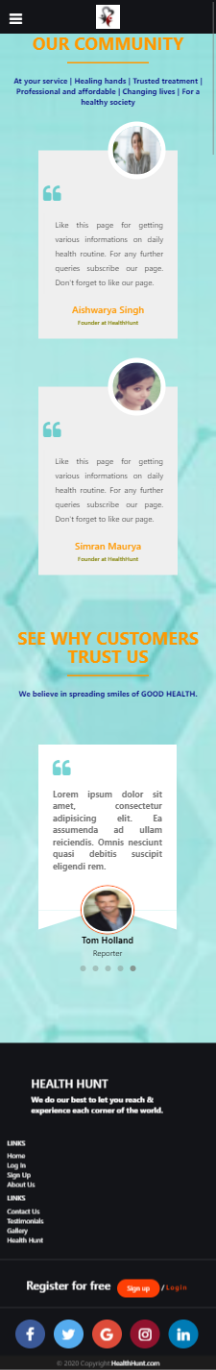

Daily Diet Page (Desktop view)

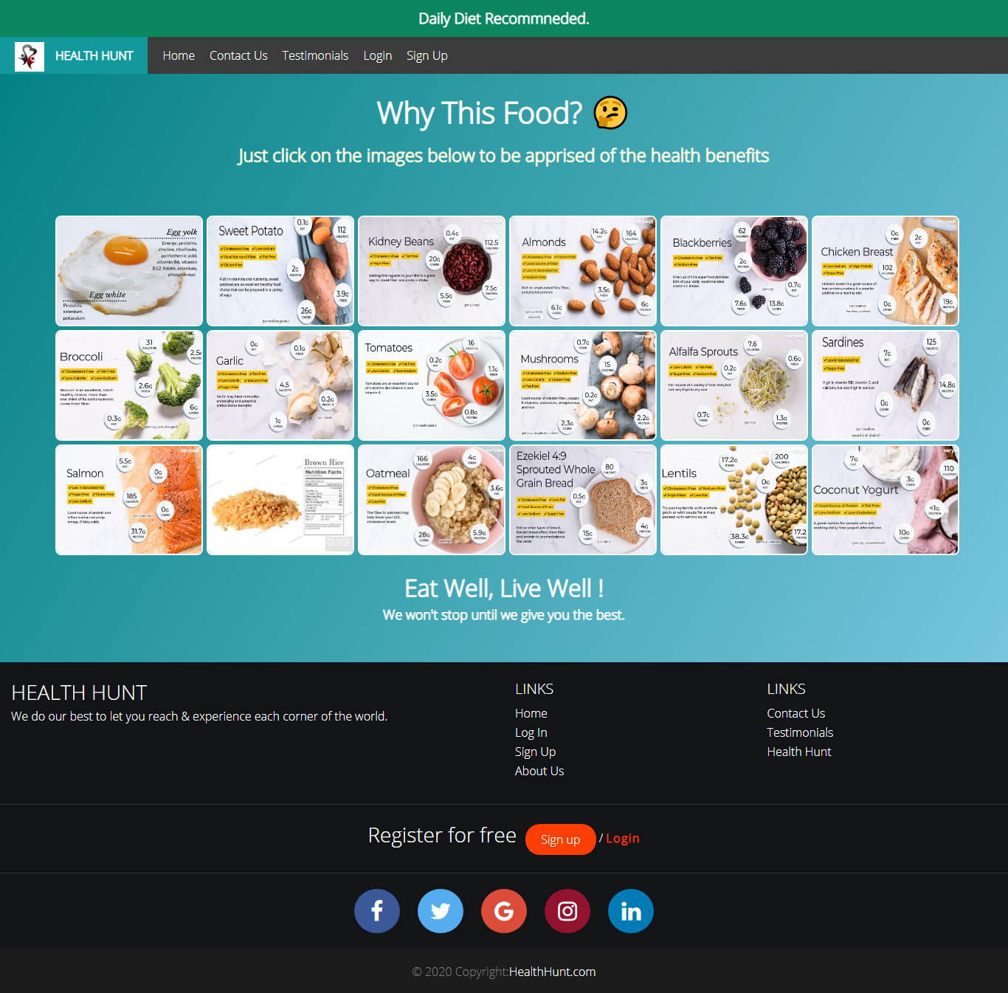

Daily Diet Page (Mobile view)

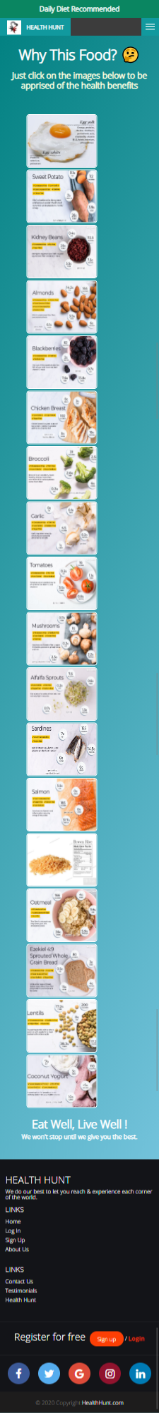

Exercise Page( Desktop View)

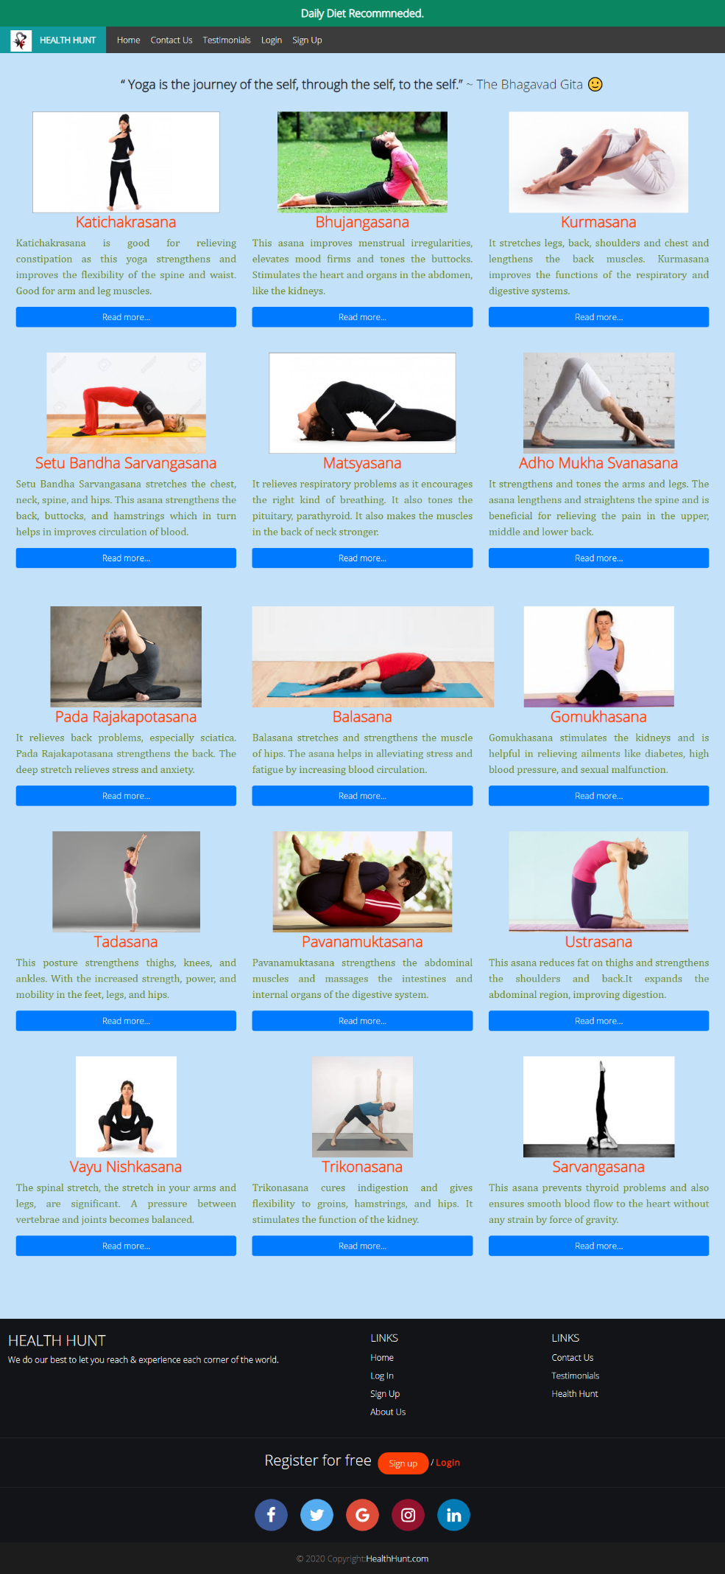

Exercise Page( Mobile View)



Mental Health Page (Desktop view)

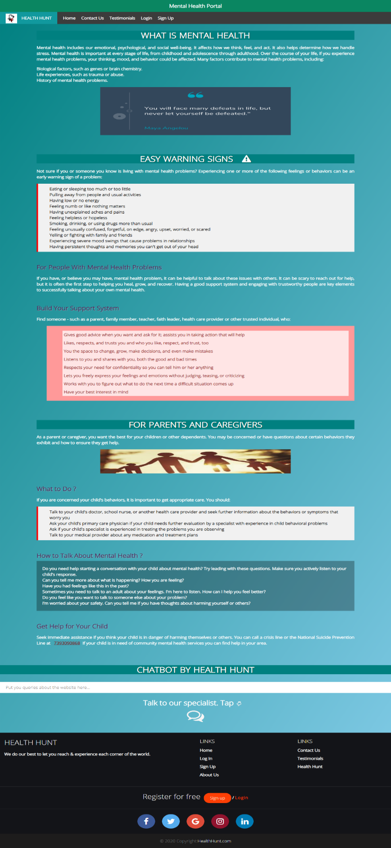

Mental Health Page (Mobile view)



About the chatbot

This is an area in the website which allows the user to get direct in touch with our specialists. Here, the user can share his/her problem without the hesitation of being judged. We assure guaranteed safety of user's identity and the problem he/she is referring to. The main purpose of this portal (two ways communication) is to help people with mental health. People have faced the consequences of depression in the pandemic. They have seen that they can't talk about their worries in public. So, this portal will let them speak their heart out. Most of the times Mental issues occur because of lack of communication. Mental and moral support are the basic necessitiesin today's time. Money and fame can never bring the inner peace which is essential for living a healthy life. So,this portal allows the user to ask queries from the “Put your queries here…” label and also provides live interaction with our specialists on user's consent. Live sessions via Zoom or any other platform will also be held to spread the idea and knowledge about basic healthy lifestyle tips. The meeting IDs will be provided to the attendees via the chatbot. The user only has to sign in once and he will get notified via mail accordingly

**To use the service, the user must do as directed:**

(i) Go to Homepage and hover over the last div saying 'Mental Health Portal'.

Once the user clicks it, he/she will be directed to the next webpage.

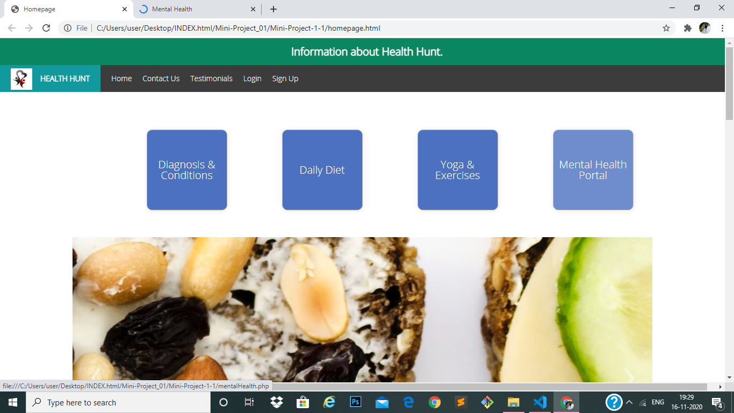

(ii) This page will let the user know about the importance of mental health and why it is necessary to put a regular check on it. This page will be helpful in building a basic understanding that brain too is a part of our body and there is no shame in talking about it.

Once the user scrolls down to the page, he/she will get a heading saying 'CHATBOT BY HEALTH HUNT'. There's a label below it saying 'Put your queries here...'. If the user is having any doubt or query regarding the portal, he/she can put it here.

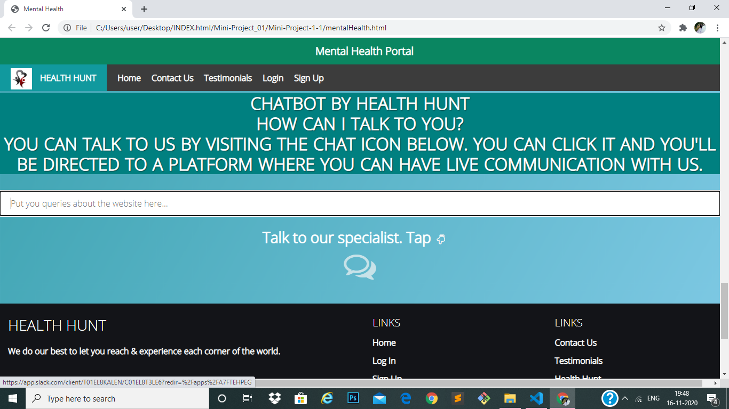

Once the question is asked by the user, an immediate reply will be directed to him/her. Here, JavaScript is playing its part in generation of automated replies.

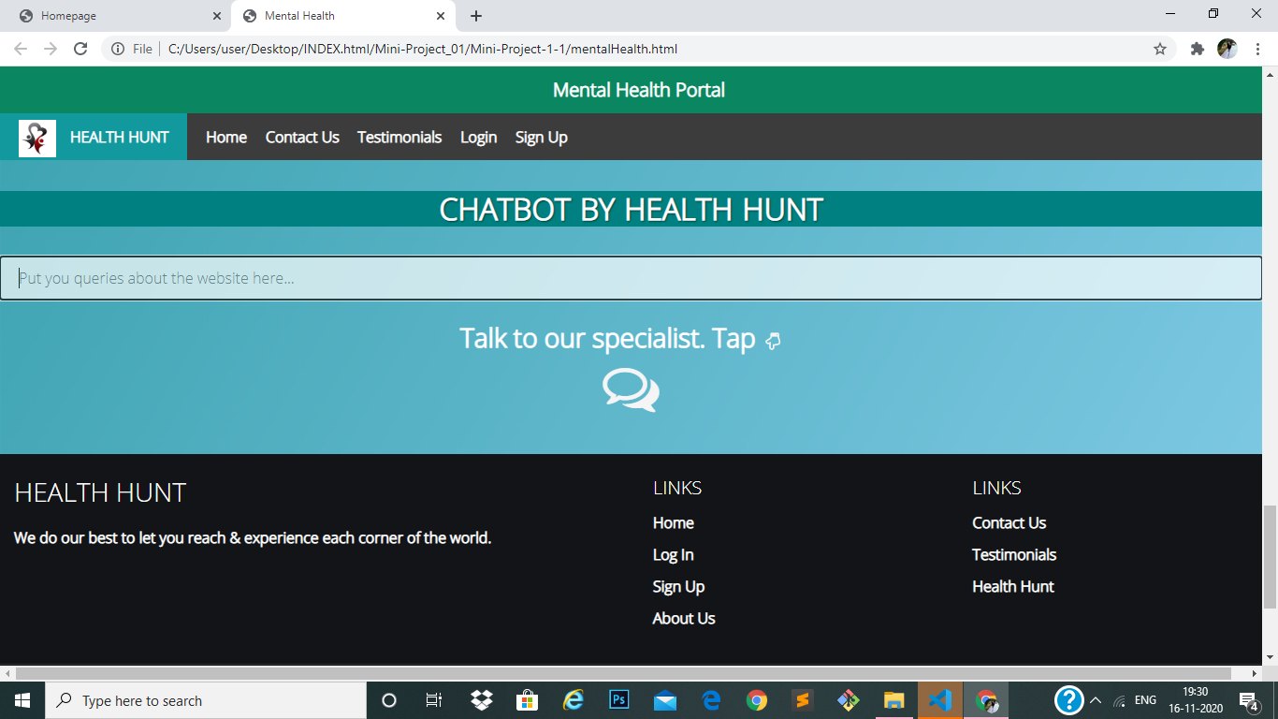

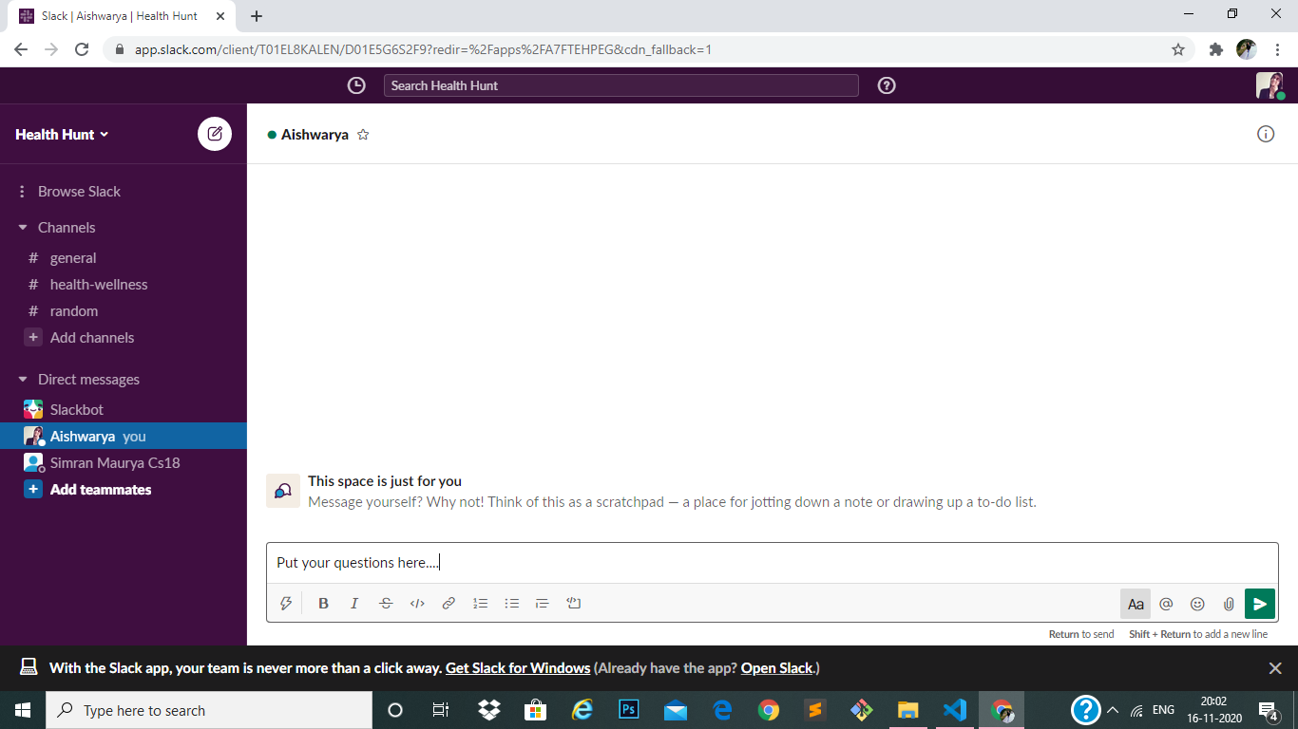(iii) The user can also have live sessions with our specialists, the chat icon below can redirect the user to a platform called Slack where he/she can search for “Health Hunt” or ask us to join. We’ll send him/her an invite link on his registered email id. The user has to login the Slack and once logged in he/she can put any of his/her queries regarding good health or healthy living. It is a two ways communication system. The meeting IDs of future sessions will be shared here which will be further notified to the user via mail.

Home Page (Desktop View)

A user needs to login through his/her email id to land at homepage. If email id is valid then homepage pops up with a welcome note at the top of the screen.

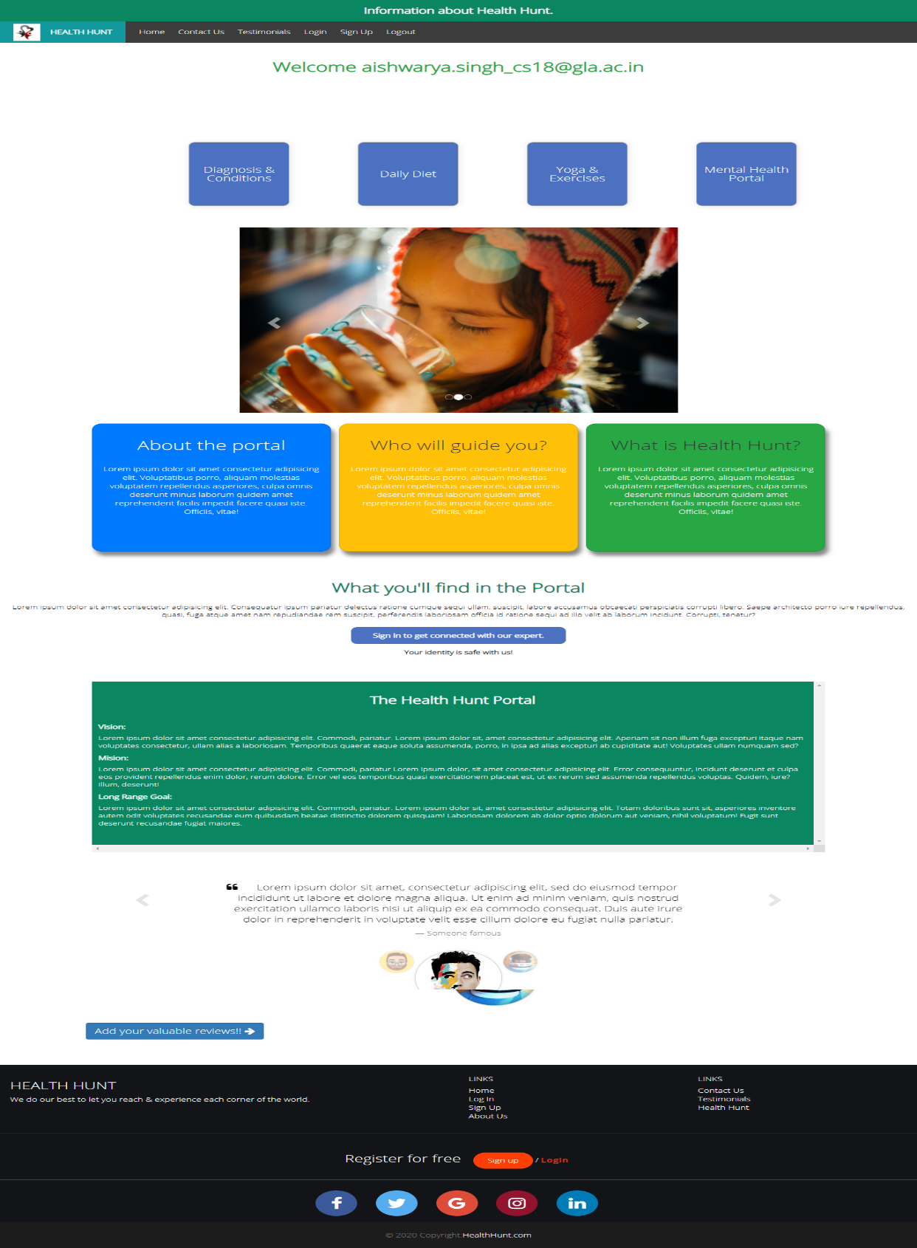

Home Page (Mobile View)

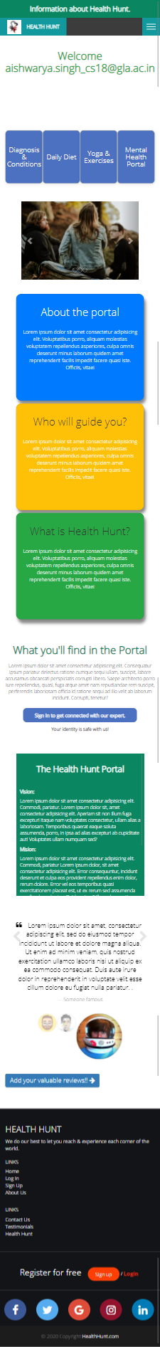

**5.SOFTWARE TESTING**

## Testing

* + - Software testing is the process of executing a program with intension of finding errors in the code. It is a process of evolution of system or its parts by manual or automatic means to verify that it is satisfying specified or requirements or not.
    - Generally, no system is perfect due to communication problems between user and developer, time constraints, or conceptual mistakes by developer.
    - To purpose of system testing is to check and find out these errors or faults as early as possible so losses due to it can be saved.
    - Testing is the fundamental process of software success.
    - Testing is not a distinct phase in system development life cycle but should be applicable throughout all phases i.e. design development and maintenance phase.
    - Testing is used to show incorrectness and considered to success when an error is detected.

## Objectives of Software Testing

* + - **Software Quality Improvement:** The computer and the software are mainly used for complex and critical applications and a bug or fault in software causes severe losses. So a great consideration is required for checking for quality of software.

#### Verification And Validation:

* + - * Verification means to test that we are building the product in right way .i.e. are we using the correct procedure for the development of software so that it can meet the user requirements.
      * Validation means to check whether we are building the right product or not.
    - **Software Reliability Estimation:** The objective is to discover the residual designing errors before delivery to the customer. The failure data during process are taken down in order to estimate the software reliability

## Principles of Software Testing

* + - All tests should be traceable to end user requirements.
    - Tests should be planned long before testing begins
    - Testing should begin on a small scale and progress towards testing in large
    - To be most effective testing should be conducted by an independent third party

The primary objective for test case design is to derive a set of tests that has the highest livelihood for uncovering defects in software. To accomplish this objective two different categories of test case design techniques are used. They are

* + - White box testing.
    - Black box testing.

#### White-box testing:

White box testing focus on the program control structure. Test cases are derived to ensure that all statements in the program have been executed at least once during testing and that all logical conditions have been executed.

#### Black-box testing:

Black box testing is designed to validate functional requirements without regard to the internal workings of a program. Black box testing mainly focuses on the information domain of the software, deriving test cases by partitioning input and output in a manner that provides through test coverage. Incorrect and missing functions, interface errors, errors in data structures, error in functional logic are the errors falling in this category.

## Testing fundamentals

Testing is a process of executing program with the intent of finding error. A good test case is one that has high probability of finding an undiscovered error. If testing is conducted successfully it uncovers the errors in the software. Testing cannot show the absence of defects, it can only show that software defects present.

## Testing Information flow:

Information flow for testing flows the pattern. Two class of input provided to test the process. The software configuration includes a software requirements specification, a design specification and source code.

Test configuration includes test plan and test cases and test tools. Tests are conducted and all the results are evaluated. That is test results are compared with expected results. When erroneous data are uncovered, an error is implied and debugging commences.

**CONCLUSION**

This was the first considerably large and important project undertaken by us during my B. Tech course. It was an experience that changed the way we perceived project development. The coding could not be started before the whole system was completely finalized. The above implementation resulted in a basic website where a user can be benefitted by following the advisory given. Online communication helped to communicate to each user. When a user isn’t logged in and tries to navigate to the above pages, he/she gets redirected to the same page of the website again. The website is user-friendly.

On the whole it was a wonderful experience developing **“HEALTH HUNT”** and we would have considered our education incomplete without undertaking such a project which allowed me to apply all that we have learnt and tried to develop a project that can be useful for the people suffering with health issues. Because of the COVID-19 pandemic, people got to know how important and precious life is. People are dealing with stress and depression every day.  Keeping that in mind our team decided to provide a platform to people where no pandemic can peep neither today nor in future. We have decided to give each and every one, a healthy and wealthy today.

**References**

1. From various Health & Wellness plans initiated by the Govt. of India.
2. <https://www.webmd.com/diet/default.htm>
3. <https://www.nhp.gov.in/healthlyliving/healthy>[-diet](https://www.nhp.gov.in/healthlyliving/healthy-diet)